R Notebook

#Converting CSV into data frame   
dat <- read.csv("New R DATA.csv")  
mrdat <- read.csv("~/Mesocosm First Pass/MR.DATA.csv")  
library(dplyr)

##   
## Attaching package: 'dplyr'

## The following object is masked from 'package:GGally':  
##   
## nasa

## The following objects are masked from 'package:stats':  
##   
## filter, lag

## The following objects are masked from 'package:lubridate':  
##   
## intersect, setdiff, union

## The following objects are masked from 'package:base':  
##   
## intersect, setdiff, setequal, union

#Creating data sets for bar graphs  
#Separating Data by Analysis Type  
MeHg <- dat %>%  
 filter(Analysis == "MeHg")  
TotHg <- dat %>%  
 filter(Analysis == "TotHg")  
#Separating MeHg by Sample Type  
sm <- MeHg %>%  
 filter(Type == "s") %>% group_by(Box) %>%  
 summarize(Mean199 = mean(X199), Mean200 = mean(X200), Mean201 = mean(X201), Mean202 = mean(X202))  
wm <- MeHg %>%   
 filter(Type == "w") %>% group_by(Box) %>%  
 summarize(Mean199 = mean(X199), Mean200 = mean(X200), Mean201 = mean(X201), Mean202 = mean(X202))  
dwm <- MeHg %>%   
 filter(Type == "dw") %>% group_by(Box) %>%  
 summarize(Mean199 = mean(X199), Mean200 = mean(X200), Mean201 = mean(X201), Mean202 = mean(X202))  
dwm <- MeHg %>%   
 filter(Type == "ds") %>% group_by(Box) %>%  
 summarize(Mean199 = mean(X199), Mean200 = mean(X200), Mean201 = mean(X201), Mean202 = mean(X202))  
bpm <- MeHg %>%   
 filter(Type == "bp") %>% group_by(Box) %>%  
 summarize(Mean199 = mean(X199), Mean200 = mean(X200), Mean201 = mean(X201), Mean202 = mean(X202))  
bbm <- MeHg %>%   
 filter(Type == "bb") %>% group_by(Box) %>%  
 summarize(Mean199 = mean(X199), Mean200 = mean(X200), Mean201 = mean(X201), Mean202 = mean(X202))  
bsm <- MeHg %>%   
 filter(Type == "bs") %>% group_by(Box) %>%  
 summarize(Mean199 = mean(X199), Mean200 = mean(X200), Mean201 = mean(X201), Mean202 = mean(X202))  
bfm <- MeHg %>%   
 filter(Type == "bf") %>% group_by(Box) %>%  
 summarize(Mean199 = mean(X199), Mean200 = mean(X200), Mean201 = mean(X201), Mean202 = mean(X202))  
#Separating Tot Hg by Sample Type  
st <- TotHg %>%   
 filter(Type == "s") %>% group_by(Box) %>%  
 summarize(Mean199 = mean(X199), Mean200 = mean(X200), Mean201 = mean(X201), Mean202 = mean(X202))  
wt <- TotHg %>%   
 filter(Type == "w") %>% group_by(Box) %>%  
 summarize(Mean199 = mean(X199), Mean200 = mean(X200), Mean201 = mean(X201), Mean202 = mean(X202))  
dwt <- TotHg %>%   
 filter(Type == "dw") %>% group_by(Box) %>%  
 summarize(Mean199 = mean(X199), Mean200 = mean(X200), Mean201 = mean(X201), Mean202 = mean(X202))  
bpt <- TotHg %>%   
 filter(Type == "bp") %>% group_by(Box) %>%  
 summarize(Mean199 = mean(X199), Mean200 = mean(X200), Mean201 = mean(X201), Mean202 = mean(X202))  
bbt <- TotHg %>%   
 filter(Type == "bb") %>% group_by(Box) %>%  
 summarize(Mean199 = mean(X199), Mean200 = mean(X200), Mean201 = mean(X201), Mean202 = mean(X202))  
bst <- TotHg %>%   
 filter(Type == "bs") %>% group_by(Box) %>%  
 summarize(Mean199 = mean(X199), Mean200 = mean(X200), Mean201 = mean(X201), Mean202 = mean(X202))  
bft <- TotHg %>%   
 filter(Type == "bf") %>% group_by(Box) %>%  
 summarize(Mean199 = mean(X199), Mean200 = mean(X200), Mean201 = mean(X201), Mean202 = mean(X202))

library(tidyr)  
#long form MeHg data for sediment, water, water DGT, plant, biofilm, fish, snail   
smp <- gather(wm, Isotope, Concentration, -Box)   
wmp <- gather(wm, Isotope, Concentration, -Box)  
dwmp <- gather(dwm, Isotope, Concentration, -Box)  
bpmp <- gather(bpm, Isotope, Concentration, -Box)  
bbmp <- gather(bbm, Isotope, Concentration, -Box)  
bfmp <- gather(bfm, Isotope, Concentration, -Box)  
bsmp <- gather(bsm, Isotope, Concentration, -Box)  
bsm16 <- bsmp %>%  
 filter(Box == "16")  
dwm16 <- dwmp %>%  
 filter(Box == "16")  
smp

## # A tibble: 12 x 3  
## Box Isotope Concentration  
## <int> <chr> <dbl>  
## 1 16 Mean199 0.171  
## 2 17 Mean199 0.287  
## 3 18 Mean199 0.155  
## 4 16 Mean200 0.247  
## 5 17 Mean200 0.470  
## 6 18 Mean200 0.268  
## 7 16 Mean201 0.424  
## 8 17 Mean201 0.808  
## 9 18 Mean201 0.475  
## 10 16 Mean202 0.475  
## 11 17 Mean202 0.912  
## 12 18 Mean202 0.512

library(ggplot2)  
require(gridExtra)

## Loading required package: gridExtra

##   
## Attaching package: 'gridExtra'

## The following object is masked from 'package:dplyr':  
##   
## combine

ggplot(smp, aes(Box, Concentration)) +   
 geom_bar(aes(fill = Isotope), position = "dodge", stat = "identity") +  
 guides(fill="none") +  
 theme_bw() +  
 labs(title = "MeHg concentration in sediment")+  
 ylab("Concentration (ng/g dw)")

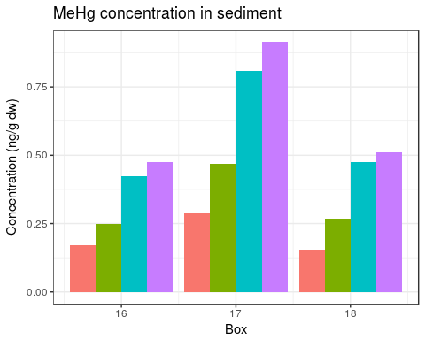

#geom_errorbar(aes(ymin=mean-sd, ymax=mean+sd), width=.2,position=position_dodge(.9))  
ggplot(wmp, aes(Box, Concentration)) +   
 geom_bar(aes(fill = Isotope), position = "dodge", stat = "identity") +  
 guides(fill="none") +  
 theme_bw() +  
labs(title = "MeHg concentration in water")+  
 ylab("Concentration (ng/l)")

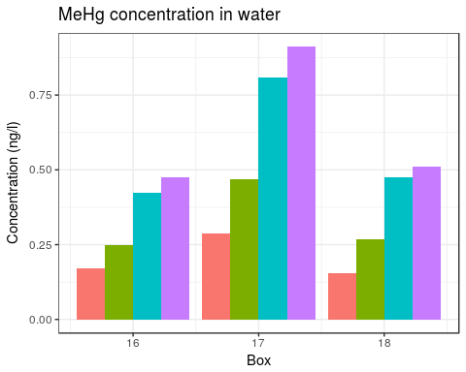

ggplot(dwmp, aes(Box, Concentration)) +   
 geom_bar(aes(fill = Isotope), position = "dodge", stat = "identity") +  
 guides(fill="none") +  
 theme_bw() +  
labs(title = "MeHg Accumulated by water DGTs (ng)")+  
 ylab("Accumulation (ng)")

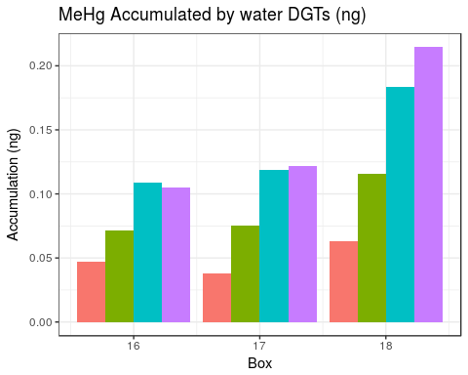

ggplot(bpmp, aes(Box, Concentration)) +   
 geom_bar(aes(fill = Isotope), position = "dodge", stat = "identity") +  
 guides(fill="none") +  
 theme_bw() +  
labs(title = "MeHg concentration in Egeria Densa")+  
 ylab("Concentration (ng/g dw)")

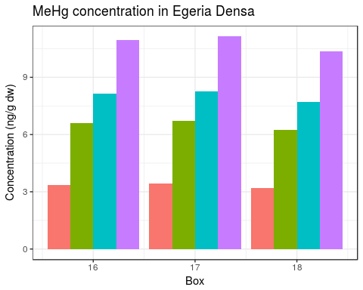

ggplot(bbmp, aes(Box, Concentration)) +   
 geom_bar(aes(fill = Isotope), position = "dodge", stat = "identity") +  
 guides(fill="none") +  
 theme_bw() +  
labs(title = "MeHg concentration in biofilms") +  
 ylab("Concentration (ng/g dw)")

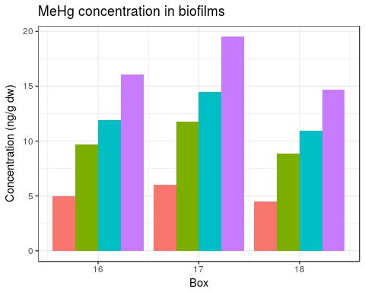

ggplot(bfmp, aes(Box, Concentration)) +   
 geom_bar(aes(fill = Isotope), position = "dodge", stat = "identity") +  
 guides(fill="none") +  
 theme_bw() +  
labs(title = "MeHg concentration in Mosquito Fish")+  
 ylab("Concentration (ng/g dw)")

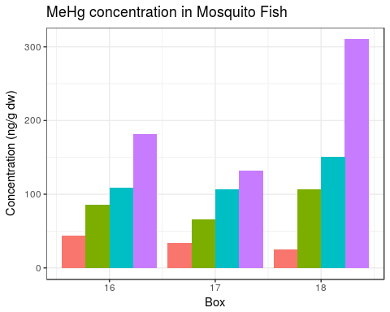

ggplot(bsmp, aes(Box, Concentration)) +   
 geom_bar(aes(fill = Isotope), position = "dodge", stat = "identity") +  
 scale_fill_discrete(name = "Endmember", labels = c("FeS-Hg", "Nano-HgS", "Hg-Humic acid", "Dissolved Hg²⁺")) +  
 theme_bw() +  
labs(title = "MeHg concentration in snails")+  
 ylab("Concentration (ng/g dw)")

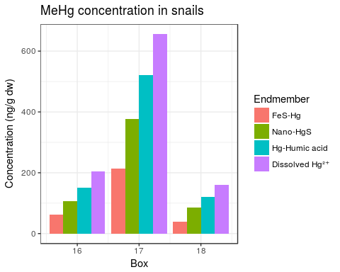

#Visualizing data with histograms to check for normalcy  
aovdat <- read.csv("~/Mesocosm First Pass/Mesocosm.6.week.data.csv")  
bf <- aovdat$bf.mehg  
bp <- aovdat$bp.mehg  
bs <- aovdat$bs.mehg  
bb <- aovdat$bb.mehg  
lbf <- log(aovdat$bf.mehg)  
lbp <- log(aovdat$bp.mehg)  
lbs <- log(aovdat$bs.mehg)  
lbb <- log(aovdat$bb.mehg)  
par(mfrow = c(2,4), mar = c(3,3,3,3))  
hist(bf, main = "Histogram of\n MeHg Conc. in Fish")  
hist(bp, main = "Histogram of\n MeHg Conc. in Plants")  
hist(bs, main = "Histogram of\n MeHg Conc. in Snails")  
hist(bb, main = "Histogram of\n MeHg Conc. in Biofilms")  
hist(lbf, main = "Histogram of\n log MeHg Conc. in Fish")  
hist(lbp, main = "Histogram of\n log MeHg Conc. in Plants")  
hist(lbs, main = "Histogram of\n log MeHg Conc in Snails")  
hist(lbb, main = "Histogram of\n log MeHg Conc. in Biofilms")

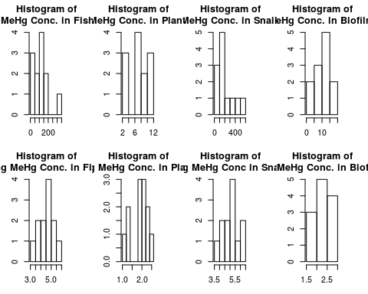

#log transforming data appears to help. Double check with Shapiro Test  
shapiro.test(bf)

##   
## Shapiro-Wilk normality test  
##   
## data: bf  
## W = 0.87794, p-value = 0.08249

shapiro.test(bp)

##   
## Shapiro-Wilk normality test  
##   
## data: bp  
## W = 0.91519, p-value = 0.2485

shapiro.test(bs)

##   
## Shapiro-Wilk normality test  
##   
## data: bs  
## W = 0.87988, p-value = 0.08734

shapiro.test(bb)

##   
## Shapiro-Wilk normality test  
##   
## data: bb  
## W = 0.96612, p-value = 0.8663

shapiro.test(lbf)

##   
## Shapiro-Wilk normality test  
##   
## data: lbf  
## W = 0.97001, p-value = 0.9109

shapiro.test(lbp)

##   
## Shapiro-Wilk normality test  
##   
## data: lbp  
## W = 0.87009, p-value = 0.06552

shapiro.test(lbs)

##   
## Shapiro-Wilk normality test  
##   
## data: lbs  
## W = 0.9847, p-value = 0.9961

shapiro.test(lbb)

##   
## Shapiro-Wilk normality test  
##   
## data: lbb  
## W = 0.93149, p-value = 0.3962

#According to results of shapiro test, log transform helped fish and snails greatly, made plants and biofilms worse (It looks like this in the histograms as well!). Therefore log fish and snails will be used; original data for plants and biofilms will be used. All seem reasonable for use.

#Updating data frame with new columns for log transformed data.   
aovdat2 <- mutate(aovdat, lbf.mehg = log(bf.mehg), lbs.mehg = log(bs.mehg))  
aovdat2[,'Box']<-factor(aovdat2[,'Box'])  
aovdat2[,'Isotope']<-factor(aovdat2[,'Isotope'])  
aovdat2

## Box Isotope s.mehg w.mehg dw.mehg bs.mehg bb.mehg  
## 1 16 199 0.7614333 0.1714833 8.789650 71.59942 4.945225  
## 2 16 200 1.5058000 0.2472333 9.923683 124.30813 9.702900  
## 3 16 201 2.4733333 0.4239500 16.963133 176.64888 11.941175  
## 4 16 202 10.3157667 0.4752333 18.450583 240.24955 16.104025  
## 5 17 199 0.3232333 0.2874833 7.528183 175.89052 5.997375  
## 6 17 200 0.5971667 0.4700667 10.579033 308.81182 11.767275  
## 7 17 201 0.9603667 0.8077667 21.189717 427.01266 14.481750  
## 8 17 202 5.1585000 0.9118333 23.942950 537.99040 19.530250  
## 9 18 199 0.2172333 0.1545833 5.571517 38.72682 4.517075  
## 10 18 200 0.4597333 0.2682000 10.957900 85.55150 8.862800  
## 11 18 201 0.7407333 0.4754500 20.629717 121.34060 10.907300  
## 12 18 202 3.2369333 0.5122667 22.882817 161.08245 14.709700  
## bp.mehg bf.mehg dw.tothg ds.mehg w.tothg s.tothg lbf.mehg  
## 1 3.367725 43.90617 0.09003333 0.04683333 1.877434 594.43620 3.782055  
## 2 6.607675 85.96747 0.16016667 0.07133333 6.056070 535.16360 4.453969  
## 3 8.131950 108.56337 0.21168333 0.10850000 7.727684 279.21925 4.687334  
## 4 10.966825 181.89327 0.28085000 0.10483333 10.917835 525.21790 5.203420  
## 5 3.422675 34.01160 0.10591667 0.03783333 3.264655 55.91757 3.526702  
## 6 6.715500 65.58767 0.18608333 0.07533333 7.522770 53.88677 4.183388  
## 7 8.264625 106.17363 0.25038333 0.11866667 9.727741 50.92157 4.665076  
## 8 11.145775 132.51487 0.32231667 0.12183333 12.280594 55.88780 4.886695  
## 9 3.185100 25.00690 0.09056667 0.06283333 1.586187 95.32717 3.219152  
## 10 6.249350 106.11325 0.18191667 0.11566667 6.236901 87.23057 4.664507  
## 11 7.690950 150.84500 0.24550000 0.18366667 8.495784 85.39013 5.016253  
## 12 10.372150 310.48345 0.31816667 0.21466667 10.924264 83.62323 5.738131  
## lbs.mehg  
## 1 4.271087  
## 2 4.822763  
## 3 5.174164  
## 4 5.481678  
## 5 5.169862  
## 6 5.732732  
## 7 6.056814  
## 8 6.287841  
## 9 3.656533  
## 10 4.449119  
## 11 4.798601  
## 12 5.081916

#First pass at simple linear regression!  
bs1 <- lm(lbs.mehg ~ dw.mehg, data = aovdat2)  
bf1 <- lm(lbf.mehg ~ dw.mehg, data = aovdat2)  
bp1 <- lm(bp.mehg ~ dw.mehg, data = aovdat2)  
bb1 <- lm(bb.mehg ~ dw.mehg, data = aovdat2)  
summary(bs1)

##   
## Call:  
## lm(formula = lbs.mehg ~ dw.mehg, data = aovdat2)  
##   
## Residuals:  
## Min 1Q Median 3Q Max   
## -0.73098 -0.42186 0.01759 0.49792 0.96777   
##   
## Coefficients:  
## Estimate Std. Error t value Pr(>|t|)   
## (Intercept) 3.96754 0.44082 9.000 4.14e-06 ***  
## dw.mehg 0.07538 0.02745 2.746 0.0206 *   
## ---  
## Signif. codes: 0 '***' 0.001 '**' 0.01 '*' 0.05 '.' 0.1 ' ' 1  
##   
## Residual standard error: 0.5965 on 10 degrees of freedom  
## Multiple R-squared: 0.4299, Adjusted R-squared: 0.3729   
## F-statistic: 7.542 on 1 and 10 DF, p-value: 0.02061

summary(bf1)

##   
## Call:  
## lm(formula = lbf.mehg ~ dw.mehg, data = aovdat2)  
##   
## Residuals:  
## Min 1Q Median 3Q Max   
## -0.48286 -0.31897 -0.03039 0.36849 0.52462   
##   
## Coefficients:  
## Estimate Std. Error t value Pr(>|t|)   
## (Intercept) 3.10220 0.28657 10.825 7.65e-07 ***  
## dw.mehg 0.09470 0.01784 5.307 0.000344 ***  
## ---  
## Signif. codes: 0 '***' 0.001 '**' 0.01 '*' 0.05 '.' 0.1 ' ' 1  
##   
## Residual standard error: 0.3878 on 10 degrees of freedom  
## Multiple R-squared: 0.738, Adjusted R-squared: 0.7118   
## F-statistic: 28.17 on 1 and 10 DF, p-value: 0.000344

summary(bp1)

##   
## Call:  
## lm(formula = bp.mehg ~ dw.mehg, data = aovdat2)  
##   
## Residuals:  
## Min 1Q Median 3Q Max   
## -1.75437 -1.05307 0.08101 0.71085 2.36720   
##   
## Coefficients:  
## Estimate Std. Error t value Pr(>|t|)   
## (Intercept) 1.43915 0.97736 1.472 0.172   
## dw.mehg 0.38809 0.06086 6.377 8.07e-05 ***  
## ---  
## Signif. codes: 0 '***' 0.001 '**' 0.01 '*' 0.05 '.' 0.1 ' ' 1  
##   
## Residual standard error: 1.323 on 10 degrees of freedom  
## Multiple R-squared: 0.8026, Adjusted R-squared: 0.7829   
## F-statistic: 40.67 on 1 and 10 DF, p-value: 8.066e-05

summary(bb1)

##   
## Call:  
## lm(formula = bb.mehg ~ dw.mehg, data = aovdat2)  
##   
## Residuals:  
## Min 1Q Median 3Q Max   
## -3.8574 -1.0133 -0.5713 1.8812 3.2652   
##   
## Coefficients:  
## Estimate Std. Error t value Pr(>|t|)   
## (Intercept) 1.9103 1.6951 1.127 0.28607   
## dw.mehg 0.6231 0.1055 5.904 0.00015 ***  
## ---  
## Signif. codes: 0 '***' 0.001 '**' 0.01 '*' 0.05 '.' 0.1 ' ' 1  
##   
## Residual standard error: 2.294 on 10 degrees of freedom  
## Multiple R-squared: 0.777, Adjusted R-squared: 0.7548   
## F-statistic: 34.85 on 1 and 10 DF, p-value: 0.0001503

#dgts appear to have a significant relationship in all cases!  
#snail p = .0206, fish p = .00344, plants p = 8.07 e-5, biofilms p = .00015

#this model does not account for blocking effect from boxes. Trying with random effects (even though I only have 4 samples/box!)  
require(lme4)

## Loading required package: lme4

## Loading required package: Matrix

##   
## Attaching package: 'Matrix'

## The following object is masked from 'package:tidyr':  
##   
## expand

bs2 <- lmer(lbs.mehg ~ dw.mehg + (1|Box), data = aovdat2)  
bf2 <- lmer(lbf.mehg ~ dw.mehg + (1|Box), data = aovdat2)  
bp2 <- lmer(bp.mehg ~ dw.mehg + (1|Box), data = aovdat2)  
bb2 <- lmer(bb.mehg ~ dw.mehg + (1|Box), data = aovdat2)  
anova(bs2)

## Analysis of Variance Table  
## Df Sum Sq Mean Sq F value  
## dw.mehg 1 2.2874 2.2874 48.085

anova(bf2)

## Analysis of Variance Table  
## Df Sum Sq Mean Sq F value  
## dw.mehg 1 4.3546 4.3546 34.382

anova(bp2)

## Analysis of Variance Table  
## Df Sum Sq Mean Sq F value  
## dw.mehg 1 71.13 71.13 40.667

anova(bb2)

## Analysis of Variance Table  
## Df Sum Sq Mean Sq F value  
## dw.mehg 1 180.85 180.85 38.752

summary(bs2)

## Linear mixed model fit by REML ['lmerMod']  
## Formula: lbs.mehg ~ dw.mehg + (1 | Box)  
## Data: aovdat2  
##   
## REML criterion at convergence: 13.6  
##   
## Scaled residuals:   
## Min 1Q Median 3Q Max   
## -1.5328 -0.5134 -0.1053 0.6982 1.4151   
##   
## Random effects:  
## Groups Name Variance Std.Dev.  
## Box (Intercept) 0.38690 0.6220   
## Residual 0.04757 0.2181   
## Number of obs: 12, groups: Box, 3  
##   
## Fixed effects:  
## Estimate Std. Error t value  
## (Intercept) 4.04155 0.39426 10.251  
## dw.mehg 0.07037 0.01015 6.934  
##   
## Correlation of Fixed Effects:  
## (Intr)  
## dw.mehg -0.381

summary(bf2)

## Linear mixed model fit by REML ['lmerMod']  
## Formula: lbf.mehg ~ dw.mehg + (1 | Box)  
## Data: aovdat2  
##   
## REML criterion at convergence: 17.7  
##   
## Scaled residuals:   
## Min 1Q Median 3Q Max   
## -1.2910 -0.6745 -0.3018 0.8217 1.3089   
##   
## Random effects:  
## Groups Name Variance Std.Dev.  
## Box (Intercept) 0.03002 0.1733   
## Residual 0.12665 0.3559   
## Number of obs: 12, groups: Box, 3  
##   
## Fixed effects:  
## Estimate Std. Error t value  
## (Intercept) 3.07472 0.28254 10.882  
## dw.mehg 0.09656 0.01647 5.864  
##   
## Correlation of Fixed Effects:  
## (Intr)  
## dw.mehg -0.862

summary(bp2)

## Linear mixed model fit by REML ['lmerMod']  
## Formula: bp.mehg ~ dw.mehg + (1 | Box)  
## Data: aovdat2  
##   
## REML criterion at convergence: 42.6  
##   
## Scaled residuals:   
## Min 1Q Median 3Q Max   
## -1.32654 -0.79626 0.06125 0.53750 1.78991   
##   
## Random effects:  
## Groups Name Variance Std.Dev.  
## Box (Intercept) 0.000 0.000   
## Residual 1.749 1.323   
## Number of obs: 12, groups: Box, 3  
##   
## Fixed effects:  
## Estimate Std. Error t value  
## (Intercept) 1.43915 0.97736 1.472  
## dw.mehg 0.38809 0.06086 6.377  
##   
## Correlation of Fixed Effects:  
## (Intr)  
## dw.mehg -0.921

summary(bb2)

## Linear mixed model fit by REML ['lmerMod']  
## Formula: bb.mehg ~ dw.mehg + (1 | Box)  
## Data: aovdat2  
##   
## REML criterion at convergence: 53.4  
##   
## Scaled residuals:   
## Min 1Q Median 3Q Max   
## -1.5077 -0.4995 -0.2203 0.7721 1.2944   
##   
## Random effects:  
## Groups Name Variance Std.Dev.  
## Box (Intercept) 0.7478 0.8648   
## Residual 4.6670 2.1603   
## Number of obs: 12, groups: Box, 3  
##   
## Fixed effects:  
## Estimate Std. Error t value  
## (Intercept) 1.93275 1.67850 1.151  
## dw.mehg 0.62158 0.09985 6.225  
##   
## Correlation of Fixed Effects:  
## (Intr)  
## dw.mehg -0.879

par(8,2)

## [[1]]  
## NULL  
##   
## [[2]]  
## NULL

plot(bs2)

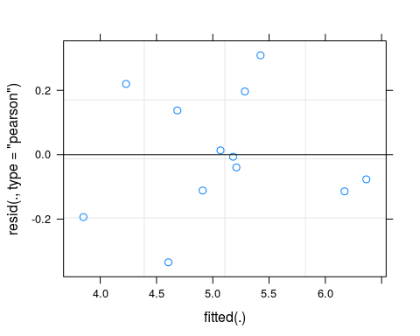

plot(bf2)

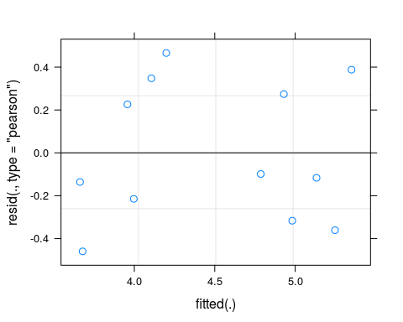

plot(bp2)

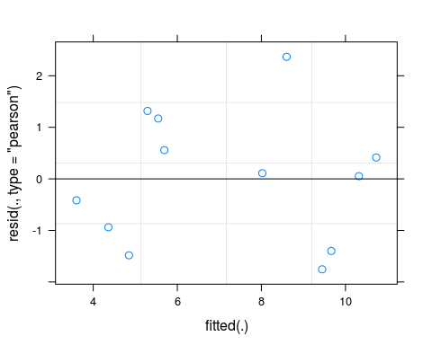

plot(bb2)

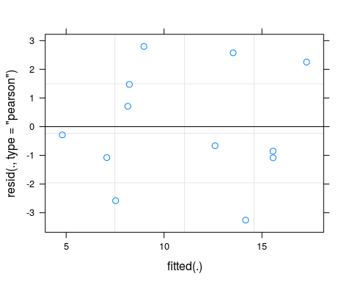

#Original - snail p = .0206, fish p = .00344, plants p = 8.07 e-5, biofilms p = .00015  
#In all cases it either stayed relatively the same or improved the outcome. Everything is still signifiant! Yay!  
#New - snail p = .0001, fish p = .0003, plants p = 8.05 e -5, biofilms p = .0002

coefbs2 <- coefficients(bs2)  
coefbf2 <- coefficients(bf2)  
coefbp2 <- coefficients(bp2)  
coefbb2 <- coefficients(bb2)  
coefbb2

## $Box  
## (Intercept) dw.mehg  
## 16 2.061452 0.6215802  
## 17 2.395307 0.6215802  
## 18 1.341493 0.6215802  
##   
## attr(,"class")  
## [1] "coef.mer"

ggplot(aovdat2, aes(x=lbs.mehg, y=dw.mehg, group=Box,shape=Isotope, colour = Box)) +   
 geom_point(aes(colour=Box)) +  
 scale_colour_manual(values=c("cyan3", "purple4","deeppink2"))+  
 geom_smooth(method = lm, se = F) +   
 xlab("1 week DGT Accumulation (ng)") +  
ylab("MeHg Conc. in Snails (ng/g dw) ") +  
 scale_shape(name = "Endmember", labels = c("FeS-Hg", "Nano-HgS", "Hg-Humic acid", "Dissolved Hg²⁺")) +  
 theme_bw()

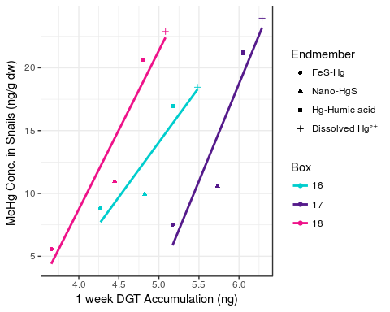

ggplot(aovdat2, aes(x=lbf.mehg, y=dw.mehg, group=Box,shape=Isotope, colour = Box)) +   
 geom_point(aes(colour=Box)) +  
 scale_colour_manual(values=c("cyan3", "purple4","deeppink2"))+  
 geom_smooth(method = lm, se = F) +   
 xlab("1 week DGT Accumulation (ng)") +  
ylab("MeHg Conc. in Fish (ng/g dw)") +  
 scale_shape(name = "Endmember", labels = c("FeS-Hg", "Nano-HgS", "Hg-Humic acid", "Dissolved Hg²⁺")) +  
 theme_bw()

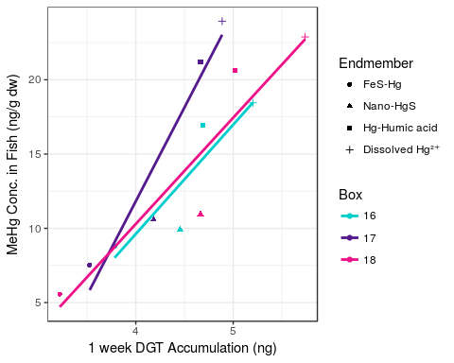

ggplot(aovdat2, aes(x=bp.mehg, y=dw.mehg, group=Box,shape=Isotope, colour = Box)) +   
 geom_point(aes(colour=Box)) +  
 scale_colour_manual(values=c("cyan3", "purple4","deeppink2"))+  
 geom_smooth(method = lm, se = F) +   
 xlab("1 week DGT Accumulation (ng)") +  
ylab("MeHg Conc. in Plants (ng/g dw)") +  
 scale_shape(name = "Endmember", labels = c("FeS-Hg", "Nano-HgS", "Hg-Humic acid", "Dissolved Hg²⁺")) +  
 theme_bw()

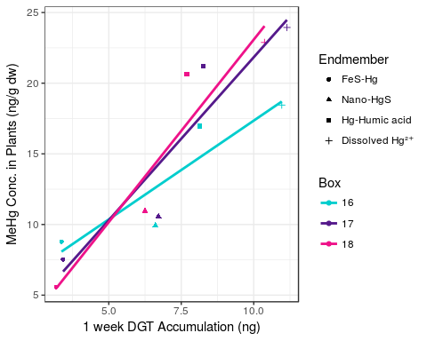

ggplot(aovdat2, aes(x=bb.mehg, y=dw.mehg, group=Box,shape=Isotope, colour = Box)) +   
 geom_point(aes(colour=Box)) +  
 scale_colour_manual(values=c("cyan3", "purple4","deeppink2"))+  
 geom_smooth(method = lm, se = F) +   
 xlab("1 week DGT Accumulation (ng)") +  
ylab("MeHg Conc. in Biofilms (ng/g dw)") +  
 scale_shape(name = "Endmember", labels = c("FeS-Hg", "Nano-HgS", "Hg-Humic acid", "Dissolved Hg²⁺")) +  
 theme_bw()

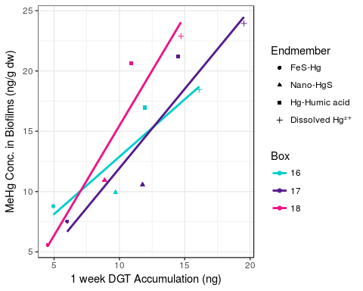

#Waaay too many variables to get a good plot. Creating separate data sets for each biota type  
bspairs <- dplyr::select(aovdat2, -bp.mehg, -bf.mehg, -bb.mehg, -lbf.mehg, -bs.mehg, -s.tothg, - Isotope, - Box)  
bfpairs <- dplyr::select(aovdat2, -bp.mehg, -lbs.mehg, -bb.mehg, -bs.mehg, - bf.mehg, -s.tothg, - Isotope, - Box)  
bppairs <- dplyr::select(aovdat2, -bf.mehg, -bb.mehg, -lbf.mehg, -lbs.mehg, - bs.mehg -s.tothg, - Isotope, - Box)  
bbpairs <- dplyr::select(aovdat2, -bp.mehg, -bf.mehg, -bs.mehg, -lbf.mehg, -lbs.mehg, -s.tothg, - Isotope, - Box)  
#plotting pairs for each biota type  
ggpairs(bspairs)

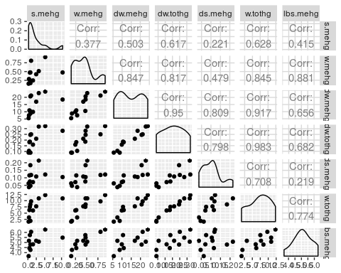

ggpairs(bfpairs)

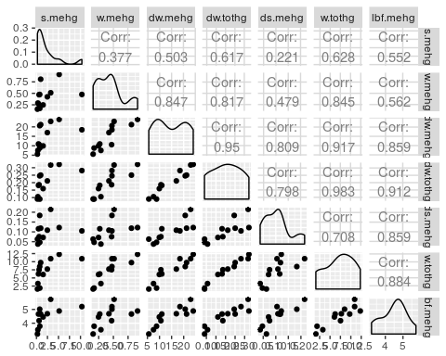

ggpairs(bppairs)

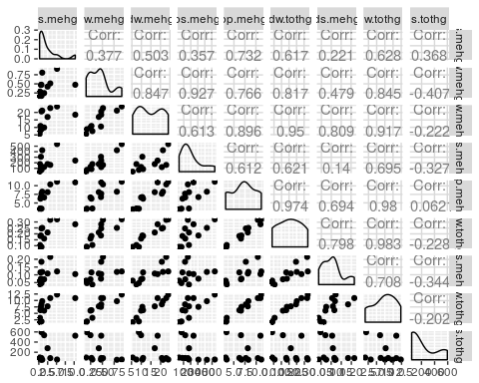

ggpairs(bbpairs)

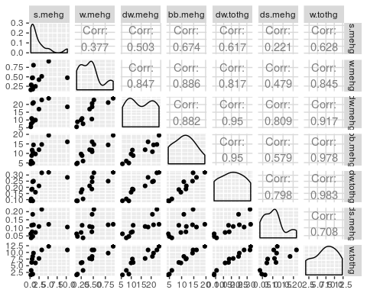

#Definitely some co-linearity among data. Will have to be careful with analysis

head(aovdat2)

## Box Isotope s.mehg w.mehg dw.mehg bs.mehg bb.mehg bp.mehg  
## 1 16 199 0.7614333 0.1714833 8.789650 71.59942 4.945225 3.367725  
## 2 16 200 1.5058000 0.2472333 9.923683 124.30813 9.702900 6.607675  
## 3 16 201 2.4733333 0.4239500 16.963133 176.64888 11.941175 8.131950  
## 4 16 202 10.3157667 0.4752333 18.450583 240.24955 16.104025 10.966825  
## 5 17 199 0.3232333 0.2874833 7.528183 175.89052 5.997375 3.422675  
## 6 17 200 0.5971667 0.4700667 10.579033 308.81182 11.767275 6.715500  
## bf.mehg dw.tothg ds.mehg w.tothg s.tothg lbf.mehg lbs.mehg  
## 1 43.90617 0.09003333 0.04683333 1.877434 594.43620 3.782055 4.271087  
## 2 85.96747 0.16016667 0.07133333 6.056070 535.16360 4.453969 4.822763  
## 3 108.56337 0.21168333 0.10850000 7.727684 279.21925 4.687334 5.174164  
## 4 181.89327 0.28085000 0.10483333 10.917835 525.21790 5.203420 5.481678  
## 5 34.01160 0.10591667 0.03783333 3.264655 55.91757 3.526702 5.169862  
## 6 65.58767 0.18608333 0.07533333 7.522770 53.88677 4.183388 5.732732

#Beginning multiple linear regression for snails. All water parameters and sediment dgts appear to be colinear. Will be considered seperately.  
require(lme4)  
require(MuMIn)

## Loading required package: MuMIn

mrbs <- lmer(lbs.mehg ~ dw.mehg + (1|Box), data = aovdat2)  
mrbs1 <- lmer(lbs.mehg ~ w.mehg + (1|Box), data = aovdat2)  
mrbs2 <- lmer(lbs.mehg ~ dw.tothg + (1|Box), data = aovdat2)  
mrbs3 <- lmer(lbs.mehg ~ w.tothg + (1|Box), data = aovdat2)  
mrbs4 <- lmer(lbs.mehg ~ ds.mehg + (1|Box), data = aovdat2)  
r.squaredGLMM(mrbs)

## Warning: 'r.squaredGLMM' now calculates a revised statistic. See the help  
## page.

## R2m R2c  
## [1,] 0.3285683 0.9264872

r.squaredGLMM(mrbs1)

## R2m R2c  
## [1,] 0.6460143 0.8691624

r.squaredGLMM(mrbs2)

## R2m R2c  
## [1,] 0.3655967 0.9815477

r.squaredGLMM(mrbs3)

## R2m R2c  
## [1,] 0.4361794 0.9909525

r.squaredGLMM(mrbs4)

## R2m R2c  
## [1,] 0.2416841 0.9675832

summary(mrbs)

## Linear mixed model fit by REML ['lmerMod']  
## Formula: lbs.mehg ~ dw.mehg + (1 | Box)  
## Data: aovdat2  
##   
## REML criterion at convergence: 13.6  
##   
## Scaled residuals:   
## Min 1Q Median 3Q Max   
## -1.5328 -0.5134 -0.1053 0.6982 1.4151   
##   
## Random effects:  
## Groups Name Variance Std.Dev.  
## Box (Intercept) 0.38690 0.6220   
## Residual 0.04757 0.2181   
## Number of obs: 12, groups: Box, 3  
##   
## Fixed effects:  
## Estimate Std. Error t value  
## (Intercept) 4.04155 0.39426 10.251  
## dw.mehg 0.07037 0.01015 6.934  
##   
## Correlation of Fixed Effects:  
## (Intr)  
## dw.mehg -0.381

summary(mrbs1)

## Linear mixed model fit by REML ['lmerMod']  
## Formula: lbs.mehg ~ w.mehg + (1 | Box)  
## Data: aovdat2  
##   
## REML criterion at convergence: 6.7  
##   
## Scaled residuals:   
## Min 1Q Median 3Q Max   
## -1.6318 -0.6901 0.2356 0.6371 1.2405   
##   
## Random effects:  
## Groups Name Variance Std.Dev.  
## Box (Intercept) 0.11022 0.3320   
## Residual 0.06463 0.2542   
## Number of obs: 12, groups: Box, 3  
##   
## Fixed effects:  
## Estimate Std. Error t value  
## (Intercept) 4.0412 0.2655 15.22  
## w.mehg 2.3992 0.3882 6.18  
##   
## Correlation of Fixed Effects:  
## (Intr)  
## w.mehg -0.634

summary(mrbs2)

## Linear mixed model fit by REML ['lmerMod']  
## Formula: lbs.mehg ~ dw.tothg + (1 | Box)  
## Data: aovdat2  
##   
## REML criterion at convergence: -6.1  
##   
## Scaled residuals:   
## Min 1Q Median 3Q Max   
## -1.3435 -0.6746 0.2367 0.7440 0.9880   
##   
## Random effects:  
## Groups Name Variance Std.Dev.  
## Box (Intercept) 0.40325 0.6350   
## Residual 0.01208 0.1099   
## Number of obs: 12, groups: Box, 3  
##   
## Fixed effects:  
## Estimate Std. Error t value  
## (Intercept) 3.8760 0.3772 10.28  
## dw.tothg 5.9219 0.4066 14.56  
##   
## Correlation of Fixed Effects:  
## (Intr)  
## dw.tothg -0.220

summary(mrbs3)

## Linear mixed model fit by REML ['lmerMod']  
## Formula: lbs.mehg ~ w.tothg + (1 | Box)  
## Data: aovdat2  
##   
## REML criterion at convergence: -5.9  
##   
## Scaled residuals:   
## Min 1Q Median 3Q Max   
## -1.5455 -0.5281 0.1775 0.5272 1.1829   
##   
## Random effects:  
## Groups Name Variance Std.Dev.  
## Box (Intercept) 0.315990 0.56213   
## Residual 0.005153 0.07179   
## Number of obs: 12, groups: Box, 3  
##   
## Fixed effects:  
## Estimate Std. Error t value  
## (Intercept) 4.071704 0.328280 12.40  
## w.tothg 0.139956 0.006208 22.54  
##   
## Correlation of Fixed Effects:  
## (Intr)  
## w.tothg -0.137

summary(mrbs4)

## Linear mixed model fit by REML ['lmerMod']  
## Formula: lbs.mehg ~ ds.mehg + (1 | Box)  
## Data: aovdat2  
##   
## REML criterion at convergence: 3.8  
##   
## Scaled residuals:   
## Min 1Q Median 3Q Max   
## -1.46117 -0.55219 -0.08911 0.42433 1.59003   
##   
## Random effects:  
## Groups Name Variance Std.Dev.  
## Box (Intercept) 0.89396 0.9455   
## Residual 0.03992 0.1998   
## Number of obs: 12, groups: Box, 3  
##   
## Fixed effects:  
## Estimate Std. Error t value  
## (Intercept) 3.9923 0.5674 7.036  
## ds.mehg 10.3612 1.3661 7.585  
##   
## Correlation of Fixed Effects:  
## (Intr)  
## ds.mehg -0.253

#sediment MeHg is not significant in any model. All others appear to be significant  
#rerunning with sediment removed  
#OK - all of these look pretty good, but water TotHg and water dgt tothg are clear winners

#Beginning multiple linear regression for fish. All water parameters and sediment dgts appear to be colinear. Will be considered seperately.  
require(lme4)  
require(MuMIn)  
mrbf <- lmer(lbf.mehg ~ dw.mehg + (1|Box), data = aovdat2)  
mrbf1 <- lmer(lbf.mehg ~ w.mehg + (1|Box), data = aovdat2)  
mrbf2 <- lmer(lbf.mehg ~ dw.tothg + (1|Box), data = aovdat2)  
mrbf3 <- lmer(lbf.mehg ~ w.tothg + (1|Box), data = aovdat2)  
mrbf4 <- lmer(lbf.mehg ~ ds.mehg + (1|Box), data = aovdat2)  
r.squaredGLMM(mrbf)

## R2m R2c  
## [1,] 0.7186915 0.7725971

r.squaredGLMM(mrbf1)

## R2m R2c  
## [1,] 0.4524169 0.8001001

r.squaredGLMM(mrbf2)

## R2m R2c  
## [1,] 0.8110085 0.898521

r.squaredGLMM(mrbf3)

## R2m R2c  
## [1,] 0.7620544 0.9163427

r.squaredGLMM(mrbf4)

## R2m R2c  
## [1,] 0.7442744 0.9175108

summary(mrbf)

## Linear mixed model fit by REML ['lmerMod']  
## Formula: lbf.mehg ~ dw.mehg + (1 | Box)  
## Data: aovdat2  
##   
## REML criterion at convergence: 17.7  
##   
## Scaled residuals:   
## Min 1Q Median 3Q Max   
## -1.2910 -0.6745 -0.3018 0.8217 1.3089   
##   
## Random effects:  
## Groups Name Variance Std.Dev.  
## Box (Intercept) 0.03002 0.1733   
## Residual 0.12665 0.3559   
## Number of obs: 12, groups: Box, 3  
##   
## Fixed effects:  
## Estimate Std. Error t value  
## (Intercept) 3.07472 0.28254 10.882  
## dw.mehg 0.09656 0.01647 5.864  
##   
## Correlation of Fixed Effects:  
## (Intr)  
## dw.mehg -0.862

summary(mrbf1)

## Linear mixed model fit by REML ['lmerMod']  
## Formula: lbf.mehg ~ w.mehg + (1 | Box)  
## Data: aovdat2  
##   
## REML criterion at convergence: 18.1  
##   
## Scaled residuals:   
## Min 1Q Median 3Q Max   
## -1.8374 -0.5841 0.1399 0.5079 1.4946   
##   
## Random effects:  
## Groups Name Variance Std.Dev.  
## Box (Intercept) 0.3497 0.5914   
## Residual 0.2011 0.4484   
## Number of obs: 12, groups: Box, 3  
##   
## Fixed effects:  
## Estimate Std. Error t value  
## (Intercept) 3.2593 0.4708 6.923  
## w.mehg 2.8652 0.6851 4.182  
##   
## Correlation of Fixed Effects:  
## (Intr)  
## w.mehg -0.631

summary(mrbf2)

## Linear mixed model fit by REML ['lmerMod']  
## Formula: lbf.mehg ~ dw.tothg + (1 | Box)  
## Data: aovdat2  
##   
## REML criterion at convergence: 2.7  
##   
## Scaled residuals:   
## Min 1Q Median 3Q Max   
## -1.8323 -0.1317 0.2150 0.4352 1.0543   
##   
## Random effects:  
## Groups Name Variance Std.Dev.  
## Box (Intercept) 0.04983 0.2232   
## Residual 0.05779 0.2404   
## Number of obs: 12, groups: Box, 3  
##   
## Fixed effects:  
## Estimate Std. Error t value  
## (Intercept) 2.8271 0.2324 12.163  
## dw.tothg 8.2260 0.8867 9.277  
##   
## Correlation of Fixed Effects:  
## (Intr)  
## dw.tothg -0.777

summary(mrbf3)

## Linear mixed model fit by REML ['lmerMod']  
## Formula: lbf.mehg ~ w.tothg + (1 | Box)  
## Data: aovdat2  
##   
## REML criterion at convergence: 10.4  
##   
## Scaled residuals:   
## Min 1Q Median 3Q Max   
## -1.7726 -0.3026 0.1367 0.5491 1.3733   
##   
## Random effects:  
## Groups Name Variance Std.Dev.  
## Box (Intercept) 0.09568 0.3093   
## Residual 0.05188 0.2278   
## Number of obs: 12, groups: Box, 3  
##   
## Fixed effects:  
## Estimate Std. Error t value  
## (Intercept) 3.10895 0.23734 13.099  
## w.tothg 0.19302 0.01965 9.824  
##   
## Correlation of Fixed Effects:  
## (Intr)  
## w.tothg -0.598

summary(mrbf4)

## Linear mixed model fit by REML ['lmerMod']  
## Formula: lbf.mehg ~ ds.mehg + (1 | Box)  
## Data: aovdat2  
##   
## REML criterion at convergence: 4.5  
##   
## Scaled residuals:   
## Min 1Q Median 3Q Max   
## -1.09623 -0.69835 -0.08054 0.37088 1.49057   
##   
## Random effects:  
## Groups Name Variance Std.Dev.  
## Box (Intercept) 0.14063 0.3750   
## Residual 0.06696 0.2588   
## Number of obs: 12, groups: Box, 3  
##   
## Fixed effects:  
## Estimate Std. Error t value  
## (Intercept) 2.9497 0.2928 10.075  
## ds.mehg 14.7621 1.7340 8.513  
##   
## Correlation of Fixed Effects:  
## (Intr)  
## ds.mehg -0.623

#OK. water dgt MeHg and water MeHg significant, but have much lower r2. Again, sediment it not significant. Removing and running again.

#Beginning multiple linear regression for biofilms. All water parameters and sediment dgts appear to be colinear. Will be considered seperately.  
require(lme4)  
require(MuMIn)  
mrbb <- lmer(bb.mehg ~ dw.mehg + (1|Box), data = aovdat2)  
mrbb1 <- lmer(bb.mehg ~ w.mehg + (1|Box), data = aovdat2)  
mrbb2 <- lmer(bb.mehg ~ dw.tothg + (1|Box), data = aovdat2)  
mrbb3 <- lmer(bb.mehg ~ w.tothg + (1|Box), data = aovdat2)  
mrbb4 <- lmer(bb.mehg ~ ds.mehg + (1|Box), data = aovdat2)  
r.squaredGLMM(mrbb)

## R2m R2c  
## [1,] 0.7539025 0.7878897

r.squaredGLMM(mrbb1)

## R2m R2c  
## [1,] 0.7841626 0.8707898

r.squaredGLMM(mrbb2)

## R2m R2c  
## [1,] 0.877458 0.9673728

r.squaredGLMM(mrbb3)

## R2m R2c  
## [1,] 0.946463 0.9655548

r.squaredGLMM(mrbb4)

## R2m R2c  
## [1,] 0.4591782 0.8333592

summary(mrbb)

## Linear mixed model fit by REML ['lmerMod']  
## Formula: bb.mehg ~ dw.mehg + (1 | Box)  
## Data: aovdat2  
##   
## REML criterion at convergence: 53.4  
##   
## Scaled residuals:   
## Min 1Q Median 3Q Max   
## -1.5077 -0.4995 -0.2203 0.7721 1.2944   
##   
## Random effects:  
## Groups Name Variance Std.Dev.  
## Box (Intercept) 0.7478 0.8648   
## Residual 4.6670 2.1603   
## Number of obs: 12, groups: Box, 3  
##   
## Fixed effects:  
## Estimate Std. Error t value  
## (Intercept) 1.93275 1.67850 1.151  
## dw.mehg 0.62158 0.09985 6.225  
##   
## Correlation of Fixed Effects:  
## (Intr)  
## dw.mehg -0.879

summary(mrbb1)

## Linear mixed model fit by REML ['lmerMod']  
## Formula: bb.mehg ~ w.mehg + (1 | Box)  
## Data: aovdat2  
##   
## REML criterion at convergence: 45.7  
##   
## Scaled residuals:   
## Min 1Q Median 3Q Max   
## -1.43647 -0.63200 0.01082 0.60872 1.54728   
##   
## Random effects:  
## Groups Name Variance Std.Dev.  
## Box (Intercept) 2.452 1.566   
## Residual 3.657 1.912   
## Number of obs: 12, groups: Box, 3  
##   
## Fixed effects:  
## Estimate Std. Error t value  
## (Intercept) 2.442 1.620 1.508  
## w.mehg 20.010 2.824 7.086  
##   
## Correlation of Fixed Effects:  
## (Intr)  
## w.mehg -0.756

summary(mrbb2)

## Linear mixed model fit by REML ['lmerMod']  
## Formula: bb.mehg ~ dw.tothg + (1 | Box)  
## Data: aovdat2  
##   
## REML criterion at convergence: 30  
##   
## Scaled residuals:   
## Min 1Q Median 3Q Max   
## -1.1836 -0.7805 0.1827 0.5380 1.1893   
##   
## Random effects:  
## Groups Name Variance Std.Dev.  
## Box (Intercept) 1.9956 1.413   
## Residual 0.7242 0.851   
## Number of obs: 12, groups: Box, 3  
##   
## Fixed effects:  
## Estimate Std. Error t value  
## (Intercept) 0.2447 1.0657 0.23  
## dw.tothg 53.4177 3.1451 16.98  
##   
## Correlation of Fixed Effects:  
## (Intr)  
## dw.tothg -0.601

summary(mrbb3)

## Linear mixed model fit by REML ['lmerMod']  
## Formula: bb.mehg ~ w.tothg + (1 | Box)  
## Data: aovdat2  
##   
## REML criterion at convergence: 34.9  
##   
## Scaled residuals:   
## Min 1Q Median 3Q Max   
## -1.4368 -0.5197 -0.1704 0.2307 1.9249   
##   
## Random effects:  
## Groups Name Variance Std.Dev.  
## Box (Intercept) 0.4037 0.6353   
## Residual 0.7283 0.8534   
## Number of obs: 12, groups: Box, 3  
##   
## Fixed effects:  
## Estimate Std. Error t value  
## (Intercept) 2.05578 0.68939 2.982  
## w.tothg 1.25606 0.07331 17.133  
##   
## Correlation of Fixed Effects:  
## (Intr)  
## w.tothg -0.768

summary(mrbb4)

## Linear mixed model fit by REML ['lmerMod']  
## Formula: bb.mehg ~ ds.mehg + (1 | Box)  
## Data: aovdat2  
##   
## REML criterion at convergence: 50.8  
##   
## Scaled residuals:   
## Min 1Q Median 3Q Max   
## -1.01545 -0.60514 -0.09762 0.37704 1.60470   
##   
## Random effects:  
## Groups Name Variance Std.Dev.  
## Box (Intercept) 15.16 3.893   
## Residual 6.75 2.598   
## Number of obs: 12, groups: Box, 3  
##   
## Fixed effects:  
## Estimate Std. Error t value  
## (Intercept) 2.509 2.996 0.837  
## ds.mehg 81.905 17.432 4.699  
##   
## Correlation of Fixed Effects:  
## (Intr)  
## ds.mehg -0.612

#Again, sediment it not significant. Removing and running again.

#Beginning multiple linear regression for fish. All water parameters and sediment dgts appear to be colinear. Will be considered seperately.  
require(lme4)  
require(MuMIn)  
mrbp <- lmer(bp.mehg ~ dw.mehg + (1|Box), data = aovdat2)  
mrbp1 <- lmer(bp.mehg ~ w.mehg + (1|Box), data = aovdat2)  
mrbp2 <- lmer(bp.mehg ~ dw.tothg + (1|Box), data = aovdat2)  
mrbp3 <- lmer(bp.mehg ~ w.tothg + (1|Box), data = aovdat2)  
mrbp4 <- lmer(bp.mehg ~ s.mehg + (1|Box), data = aovdat2)  
r.squaredGLMM(mrbp)

## R2m R2c  
## [1,] 0.7870994 0.7870994

r.squaredGLMM(mrbp1)

## R2m R2c  
## [1,] 0.6356237 0.8634578

r.squaredGLMM(mrbp2)

## R2m R2c  
## [1,] 0.9390253 0.9800955

r.squaredGLMM(mrbp3)

## R2m R2c  
## [1,] 0.9509112 0.9841803

r.squaredGLMM(mrbp4)

## R2m R2c  
## [1,] 0.5119146 0.5119146

summary(mrbp)

## Linear mixed model fit by REML ['lmerMod']  
## Formula: bp.mehg ~ dw.mehg + (1 | Box)  
## Data: aovdat2  
##   
## REML criterion at convergence: 42.6  
##   
## Scaled residuals:   
## Min 1Q Median 3Q Max   
## -1.32654 -0.79626 0.06125 0.53750 1.78991   
##   
## Random effects:  
## Groups Name Variance Std.Dev.  
## Box (Intercept) 0.000 0.000   
## Residual 1.749 1.323   
## Number of obs: 12, groups: Box, 3  
##   
## Fixed effects:  
## Estimate Std. Error t value  
## (Intercept) 1.43915 0.97736 1.472  
## dw.mehg 0.38809 0.06086 6.377  
##   
## Correlation of Fixed Effects:  
## (Intr)  
## dw.mehg -0.921

summary(mrbp1)

## Linear mixed model fit by REML ['lmerMod']  
## Formula: bp.mehg ~ w.mehg + (1 | Box)  
## Data: aovdat2  
##   
## REML criterion at convergence: 40.6  
##   
## Scaled residuals:   
## Min 1Q Median 3Q Max   
## -1.29448 -0.54603 -0.06772 0.47688 1.47108   
##   
## Random effects:  
## Groups Name Variance Std.Dev.  
## Box (Intercept) 3.193 1.787   
## Residual 1.913 1.383   
## Number of obs: 12, groups: Box, 3  
##   
## Fixed effects:  
## Estimate Std. Error t value  
## (Intercept) 1.678 1.436 1.168  
## w.mehg 12.676 2.111 6.004  
##   
## Correlation of Fixed Effects:  
## (Intr)  
## w.mehg -0.638

summary(mrbp2)

## Linear mixed model fit by REML ['lmerMod']  
## Formula: bp.mehg ~ dw.tothg + (1 | Box)  
## Data: aovdat2  
##   
## REML criterion at convergence: 15  
##   
## Scaled residuals:   
## Min 1Q Median 3Q Max   
## -1.3061 -0.7439 0.1656 0.7277 1.2266   
##   
## Random effects:  
## Groups Name Variance Std.Dev.  
## Box (Intercept) 0.3520 0.5933   
## Residual 0.1706 0.4131   
## Number of obs: 12, groups: Box, 3  
##   
## Fixed effects:  
## Estimate Std. Error t value  
## (Intercept) 0.1836 0.4776 0.384  
## dw.tothg 34.3416 1.5261 22.503  
##   
## Correlation of Fixed Effects:  
## (Intr)  
## dw.tothg -0.651

summary(mrbp3)

## Linear mixed model fit by REML ['lmerMod']  
## Formula: bp.mehg ~ w.tothg + (1 | Box)  
## Data: aovdat2  
##   
## REML criterion at convergence: 20.3  
##   
## Scaled residuals:   
## Min 1Q Median 3Q Max   
## -1.44897 -0.45589 -0.09673 0.61430 1.38706   
##   
## Random effects:  
## Groups Name Variance Std.Dev.  
## Box (Intercept) 0.2866 0.5353   
## Residual 0.1363 0.3692   
## Number of obs: 12, groups: Box, 3  
##   
## Fixed effects:  
## Estimate Std. Error t value  
## (Intercept) 1.37594 0.39969 3.443  
## w.tothg 0.80363 0.03185 25.229  
##   
## Correlation of Fixed Effects:  
## (Intr)  
## w.tothg -0.575

summary(mrbp4)

## Linear mixed model fit by REML ['lmerMod']  
## Formula: bp.mehg ~ s.mehg + (1 | Box)  
## Data: aovdat2  
##   
## REML criterion at convergence: 49.6  
##   
## Scaled residuals:   
## Min 1Q Median 3Q Max   
## -1.3663 -1.0086 0.2503 0.8131 1.2242   
##   
## Random effects:  
## Groups Name Variance Std.Dev.   
## Box (Intercept) 3.887e-16 1.972e-08  
## Residual 4.115e+00 2.028e+00  
## Number of obs: 12, groups: Box, 3  
##   
## Fixed effects:  
## Estimate Std. Error t value  
## (Intercept) 5.6011 0.7470 7.498  
## s.mehg 0.7068 0.2081 3.397  
##   
## Correlation of Fixed Effects:  
## (Intr)  
## s.mehg -0.621

#OK. water dgt MeHg and water MeHg significant, but have much lower r2. Again, sediment it not significant. Removing and running again.

ggplot(aovdat2, aes(x=lbs.mehg, y=dw.tothg, group=Box,shape=Isotope, colour = Box)) +   
 geom_point(aes(colour=Box)) +  
 scale_colour_manual(values=c("cyan3", "purple4","deeppink2"))+  
 geom_smooth(method = lm, se = F) +   
 xlab("1 week DGT Accumulation (ng)") +  
ylab("MeHg Conc. in Snails (ng/g dw) ") +  
 scale_shape(name = "Endmember", labels = c("FeS-Hg", "Nano-HgS", "Hg-Humic acid", "Dissolved Hg²⁺")) +  
 theme_bw()

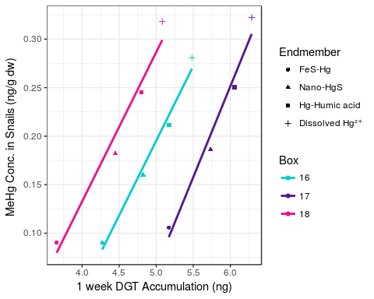

ggplot(aovdat2, aes(x=lbf.mehg, y=dw.tothg, group=Box,shape=Isotope, colour = Box)) +   
 geom_point(aes(colour=Box)) +  
 scale_colour_manual(values=c("cyan3", "purple4","deeppink2"))+  
 geom_smooth(method = lm, se = F) +   
 xlab("1 week DGT Accumulation (ng)") +  
ylab("MeHg Conc. in Fish (ng/g dw)") +  
 scale_shape(name = "Endmember", labels = c("FeS-Hg", "Nano-HgS", "Hg-Humic acid", "Dissolved Hg²⁺")) +  
 theme_bw()

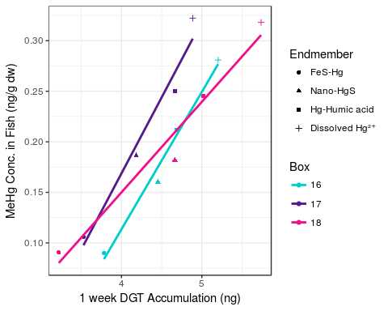

ggplot(aovdat2, aes(x=bp.mehg, y=dw.tothg, group=Box,shape=Isotope, colour = Box)) +   
 geom_point(aes(colour=Box)) +  
 scale_colour_manual(values=c("cyan3", "purple4","deeppink2"))+  
 geom_smooth(method = lm, se = F) +   
 xlab("1 week DGT Accumulation (ng)") +  
ylab("MeHg Conc. in Plants (ng/g dw)") +  
 scale_shape(name = "Endmember", labels = c("FeS-Hg", "Nano-HgS", "Hg-Humic acid", "Dissolved Hg²⁺")) +  
 theme_bw()

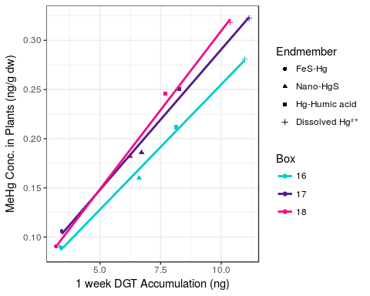

ggplot(aovdat2, aes(x=bb.mehg, y=dw.tothg, group=Box,shape=Isotope, colour = Box)) +   
 geom_point(aes(colour=Box)) +  
 scale_colour_manual(values=c("cyan3", "purple4","deeppink2"))+  
 geom_smooth(method = lm, se = F) +   
 xlab("1 week DGT Accumulation (ng)") +  
ylab("MeHg Conc. in Biofilms (ng/g dw)") +  
 scale_shape(name = "Endmember", labels = c("FeS-Hg", "Nano-HgS", "Hg-Humic acid", "Dissolved Hg²⁺")) +  
 theme_bw()

